EX.NO: 09 | GENERIC MAXIMUM
DATE:20-9-2019 | GENERIC MAXIMUM

AIM: To develop a java program for the maximum value from the given type of element using a generic function.

REQUIREMENT: To find the maximum value from the given type of element using Generic function.

ALGORITHM:
STEP 1: Create a package called as maximum.
STEP 2: Create a class GenericMaximum.
STEP 3: Declare a method with initial attributes.
STEP 4: Apply a suitable condition loop to it.
STEP 5: Declare a object in it.
STEP 6: Print the result.

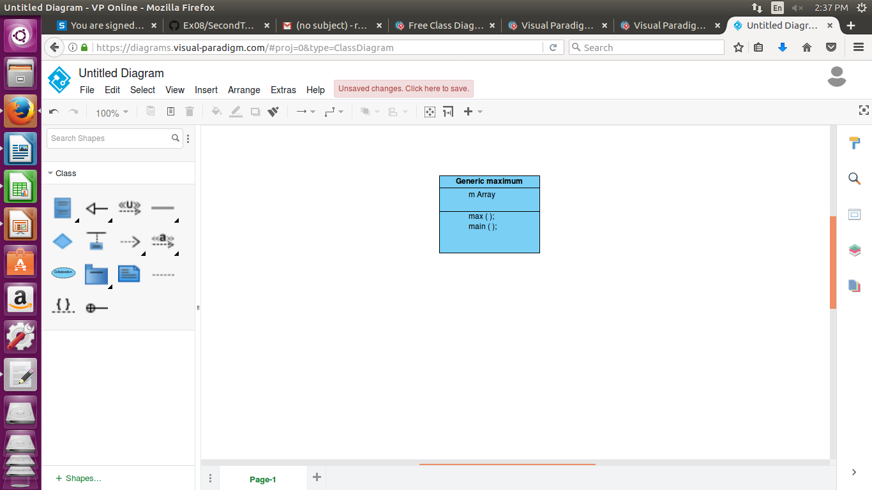
CLASS DIAGRAM:

PROGRAM:
/*
* developed by A.sandhiya
* EEE-B
* 212217105052
*
*
*/
package maximum;

public class GenericMaximum {

public static <E extends Comparable<E>> E Max(E[] ele)
{
E m;
m=ele[0];
for(E e:ele)
{
if(e.compareTo(m)>0) {
m=e;
}
}

return m;

}

public static void main(String[] args) {
Integer[] intArray = { 6,4,8,9};
Integer intMax;
Double[] doubleArray = {1.1,6.4,8.9,3.0};
Double doubleMax;
String[] stringArray = {"Arumugam","Sarguna","Sandhiya"};
String strMax;
intMax=GenericMaximum.Max(intArray);
System.out.println("Integer Max="+intMax);
strMax=GenericMaximum.Max(stringArray);
System.out.println("String Max="+strMax);
doubleMax=GenericMaximum.Max(doubleArray);
System.out.println("Double Max="+doubleMax);

}

}

OUTPUT:
Integer Max=9
String Max=Sarguna
Double Max=8.9

RESULT: Thus the java console application to find the maximum value of the given data type is developed.

